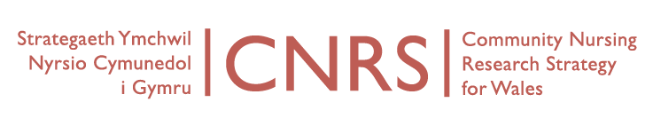
Wednesday, 6th January 2016, 11-1
Board Meeting
Venue: University of South Wales, Aneurin Bevan Building, Room AB115, Lower Glyn Taf Campus, Pontypridd CF37 4BD.
Directions: http://findaroom.southwales.ac.uk/rooms/gtab115
Video conferencing IP address: 194.83.178.242
AGENDA
Attending: Sian Bolton (PHW, in place of Rhiannon Beumount-Wood), Lindsey Peddle (Acting Team Leader/Operational Manager for Cardiff Flying Start – attending in place of Jane Imperato), Anthony Porter (ABM ULHB, attending in place of Tanya Spriggs), Caroline Williams (Hywel Dda UHB)
Videoconference: Jayne Sankey (BCUHB), has not reconfirmed
Dialling in: Marie Lewis (Powys THB), dialling in at 11:30am
Apologies: Judith Carrier (CU), Jane Imperato (Cardiff & Vale UHB), Adrian Jones (BCUHB), Janet Quarmby (BCUHB), Anthony Porter (ABM ULHB), Tanya Spriggs (ABM ULHB), Jean White (WG), Welcome and Introductions (Apologies)
- Notes of last meeting held 14th October 2015
- Matters arising
  - Joanna Briggs Institute
- Report on Coordinator activity this quarter (CW)
- CNRS updates
  - CNRS Portfolio Studies
  - Developing Industry Research
  - Bevan Commission
- Future projects or Collaborations
- CNRS Research themes and leads:
  - Organisational change and service redesign
  - Nursing roles
  - Skill mix
  - Evidence and outcomes
  - Education and development
  - Long-term care
  - Occupational health
  - Patient safety
  - Patient and user perspectives
- Next CNRS conference – 2016 (bi-annual)
- AOB
- Dates of next meetings:
  - 13 April 2016, 11-1, University of South Wales.

