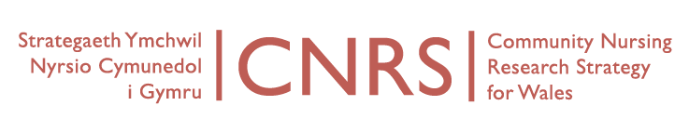
Wednesday, 13th April 2016, 11-1
Board Meeting
Venue: University of South Wales, Aneurin Bevan Building, Room AB115, Lower Glyn Taf Campus, Pontypridd CF37 4BD.
Directions: http://findaroom.southwales.ac.uk/rooms/gtab115
AGENDA
Attending:
Videoconference:
Dialling in: Marie Lewis (Powys tHB)
Apologies: Sue Bale (AB UHB), Rhiannon Beaumount-Wood (PHW), Sian Bolton (PHW), Adrian Jones (BCUHB), Louise Lidbury (RCN Wales), Ruth Northway (USW), Nicola Summers (Powys tHB), Sue Thomas (USW), Lucie Warren (CU)
- Notes of last meeting held 6th January 2016
- Matters arising
  - Developing principles for community nursing
- Report on Coordinator activity this quarter (CW)
- CNRS updates
  - CNRS Portfolio Studies
  - Developing Industry Research
  - Bevan Commission
- Future projects or collaborations
- CNRS Research themes and leads:
  - Organisational change and service redesign
  - Nursing roles
  - Skill mix
  - Evidence and outcomes
  - Education and development
  - Long-term care
  - Occupational health
  - Patient safety
  - Patient and user perspectives
- Next CNRS conference – 2016 (bi-annual)
- AOB
- Dates of next meetings:
  - 6 July 2016, 1-3, University of South Wales.

